# Dark Horse

## Ideation

Before starting our brainstorming sessions, we focused on defining the most critical issues based on our need finding research. As a result we emphasized the following three issues:

* **Broken Wheelchair** (Figure 1: Broken wheelchair - user unknown) – This is one of the most notorious issues faced by wheelchair users. To understand the dimension of this problem, Channel 4 made an interview with a wheelchair and pointed out that his wheelchair had been damaged on four out of eight flights he took. This is quite critical, especially when we take in that wheelchairs represent independence outside the plane for them and that this mishandling causes a great deal of anxiety on them during the flight.

## C:\Users\Luiz\Dropbox\Benchmarking-NeedFinding\DarkHorse\DarkHorseV1BR copy.key\Data\pasted-image-small-3.png

Figure : Broken wheelchair – Unknown user

* **Small Pitch** (Figure 2: Characterization of the small pitch - unknown author) – The small space between rows of seats is not a novelty to anybody who has already been on a commercial airplane. For people with reduced mobility the small pitch represents an increase of one’s limitation and a growing feeling that one is bothering other people. One feels like a sardine in a can, unable to get in/out of one’s seat.

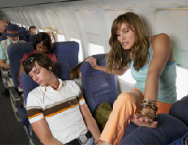

Figure : Characterization of the small pitch - unknown author

* **Inaccessible WC’s** (Figure 3: Small Lavatory) – the inaccessibility of lavatories is another important issue that people with reduced mobility travelling on airplanes have to face. As our field research showed, people with reduced mobility take extreme measures to avoid going to the airplane lavatory because they are so tiny that they most of the times aren’t able to transfer themselves to the toiled seat and enjoy some privacy while inside it. As a result, users feel dependent on others.

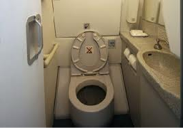

Figure : Small Lavatory

## Dark Horse Candidates

The following Dark Horse ideas were generated during our brainstorming sessions:

* **Mobile W.C**. (Figure 4: Mobile W.C.) – The basic idea here is having a portable lavatory that can move closer to the user eliminating the difficult process of walking to the W.C., providing the user with autonomy. Nevertheless, as we thought further on the idea and asked other people about their impressions, we noticed that it was highly controversial because it would be very difficult to deal with hygiene, privacy and odors. Any failure on the mechanism would be catastrophic.

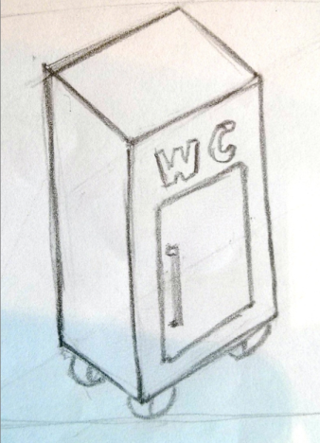

Figure : Mobile W.C.

* **Integrated Toilet Seat** (Figure 5: Integrated Toilet Seat) – It consists in a module that would be installed bellow each seat giving even more autonomy to the user once one did not need to call a flight attendant to go to the lavatory. Nonetheless, this solution had the same cons as listed on the previous solution, besides a considerable increase the plane´s weight.

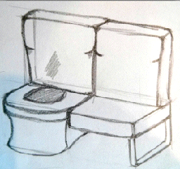

Figure : Integrated Toilet Seat

* **Modular Boarding** (Figure 6: Modular Boarding) – It consists of a mechanism similar to one of a rollercoaster. For this idea the group discussed two different forms to operate. On the first one, the plane would be just an exoskeleton receiving all the seats together; on the second one, each seat would individually be transferred from the boarding area to the interior of the plane. This solution eliminates the space constraint issue by allowing passengers to board outside of the plane and at the same time makes the boarding/exiting process faster. However, this solution would require changes in airports and increase of the airplane’s weight. Lastly, because this solution would have a similar mechanism as our CFP, we discarded it as it would generate less significant insights

## C:\Users\Luiz\Dropbox\Benchmarking-NeedFinding\DarkHorse\DarkHorseV1BR copy.key\Data\rejected-small.pngC:\Users\Luiz\Dropbox\Benchmarking-NeedFinding\DarkHorse\DarkHorseV1BR copy.key\Data\pasted-image-small-10.png

Figure : Modular Boarding

* **Hardcase for Wheelchairs** (Figure 7: Hardcase for Wheelchair) – The universal hardcase for wheelchairs was conceived to reduce the number of wheelchairs damaged in flights, which represents a huge cause of anxiety for users. As a consequence, this would improve the disabled passengers’ experience and reduce the costs with compensations provided by airlines. Nevertheless, the group did not have enough knowledge concerning the wheelchair storage procedure, making this solution not viable for the Dark Horse.

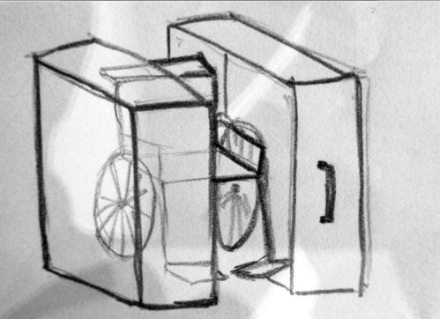

Figure : Hardcase for Wheelchair

* **Universal Seat** (Figure 8) - The universal seat was inspired on the inspector gadget character and would provide users with instruments to satisfy individual needs. This solution was discussed thoroughly but discarded because it would significantly increase the weight of the plane and also require a lot of time to integrate solutions that are not even available on the market nowadays.

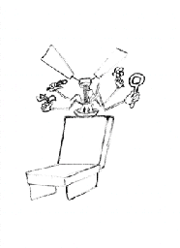

Figure : Universal Seat

* **Rotating Access Seats for WCs** (Figure 9) – It is a rotating seat on the lavatory’s wall to aid reduced mobility passengers to access the W.C. It provides maneuver space for the user to be transferred to the lavatory without increasing its size and improves privacy by allowing wheelchair users to close the door. It is a universal solution because it does not segregate a lavatory for specific users. On the other hand, this idea would increase weight and we still did not know how the user would react while using the mechanism. This idea was chosen to be the Dark Horse project.

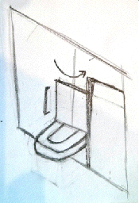

Figure : Rotating Access Seats for W.C.s

## Benchmarking

### Version 1.0

Our vision for what we wanted to accomplish with our Dark Horse prototype led us to examine different types of lavatory both accessible or not and being part of an airplane or not. Considering this aspects we achieve the following research:

* **Current Airplane Lavatory** (Figure 10: Current W.C. on the airplane) – By studying the current W.C. we were able to recognize the most critical aspects of the imperfections of the lavatory such as the space to maneuver and, related to that, the lack of privacy once it is necessary to let the door open for the aisle chair.

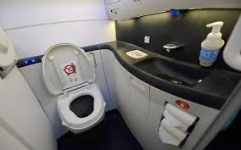

Figure : Current W.C. on the airplane

* **Accessible lavatory** (Figure 11: Accessible lavatory) – By analyzing an accessible non-airplane lavatory we were able to understand the needs, concerning the bathroom, of people with reduced mobility and get to know the adaptations that exists nowadays.

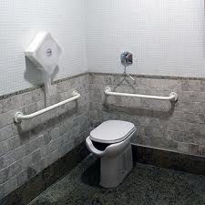

Figure : Accessible lavatory

It is possible to observe the bars on the right side of the toilet and also on its back, used to facilitate the transfer in and out the seat; the adapted flush that allows the user to flush while seated on his wheelchair; and at least but not last, the adapted toilet that allows male users to urinate while seated on their wheelchair.

* **Regulation for accessible lavatory design** (Figure 12: Regulation for accessible lavatory design) – Also concerning the accessible toilet, it is important to understand the regulation that covers the construction of an adapted lavatory. In Brazil, this is the ABNT (Brazilian association of technical standards in the Portuguese acronym) – 9050 of 2004.

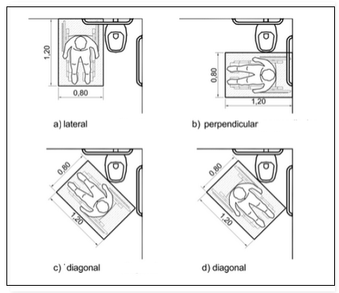

Figure : Regulation for accessible lavatory design

It is possible to understand from this regulation the current transfer process and the space required by the users to have their independence.

* **Lavatory of the Boing 787 Dreamliner** (Figure 13: Convertible lavatory) - *“The Dreamliner features two wheelchair-accessible lavatories, each with significant advancements. The 56-inch longitudinal lavatory repositions the entryway door and toilet to provide extra usable space and makes it easier for passengers to reach and use the facilities. A 56-inch by 57-inch convertible lavatory includes a movable center wall that allows two separate lavatories to become one large, wheelchair-accessible facility. Other wheelchair-accessible lavatory improvements include an additional toilet-flush button on the sink cabinet and a fold-down assist bar to aid independent transfers*.” According to the following website, <http://pvamag.com/pn/article/4576/accessible_skies> - accessed 03/15/2014 4:08PM

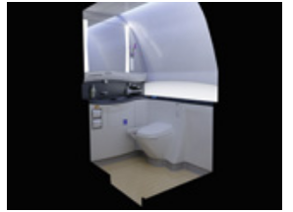

Figure : Convertible lavatory

* **Dual pivot expandable lavatory** (Figure 14: Dual pivot expandable lavatory).- The lavatory may be positioned proximate to the doorway area of the airplane, and is provided with a primary and a secondary pivotable module. Each module is pivotally attached to a stationary assembly conventionally affixed to the ceiling and floor of the airplane. During take-off and landing both modules are locked, by means of a locking system, in a stowed position within the stationary assembly. During routine flight, the locking system is unlocked and both modules are pivoted into a deployed position within the doorway area. A flight attendant's seat may be affixed to the exterior of the primary module. If the seat is used, an additional support foot is affixed to the primary module to accommodate the additional loading on the lavatory. According to the US patent 6079669.

<http://www.google.nl/patents/US6079669> - accessed 01/10/2014 3:38PM

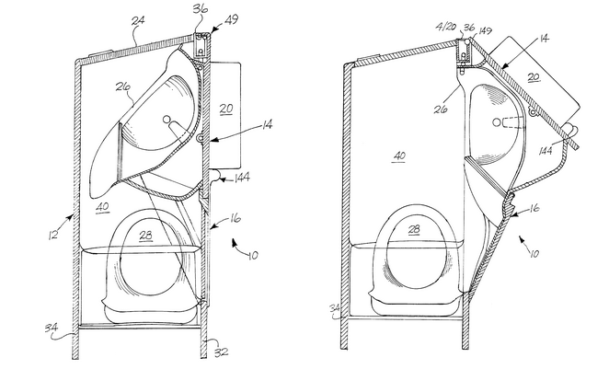

Figure : Dual pivot expandable lavatory

* **Aircraft lavatory for a person with reduced mobility** (Figure 15: Aircraft lavatory for a person with reduced mobility) - An aircraft lavatory includes first and third walls extending inwardly from a second wall and a fourth wall connecting the first wall to the third wall. A countertop extends along a portion of the first wall. A sink is disposed in the countertop. The countertop defines an under-countertop recess free from obstructions. A toilet is disposed adjacent to both the second wall and the third wall and defines a toilet axis bisecting the toilet. A door extends along at least a portion of the third wall. An access axis is defined that is disposed at an access angle with respect to the toilet axis. When a person in a wheelchair enters the lavatory area along the access axis, the countertop recess accommodates at least a portion of the person's body. According to the US patent 20120261509 A1.

<https://www.google.com/patents/US20120261509> - accessed 01/10/2014 4:38PM

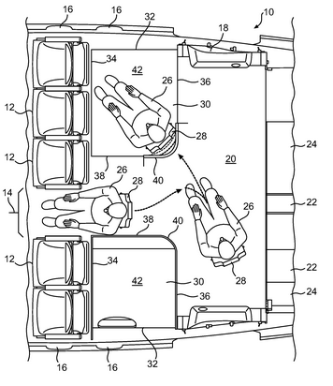

Figure : Aircraft lavatory for a person with reduced mobility

### Version 2.0

For this version of the dark horse prototype we looked for rotating mechanism in which we could base our own. For this we considered the following things

* **Pivoting Door** (Figure 16: Pivoting door) - This mechanism allows door to turn 360° and cold be used to build the turning of the wall.

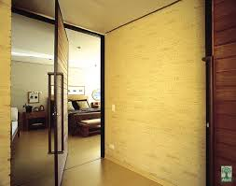

Figure : Pivoting door

* **Crank Rod** (Figure 17) - This mechanism is used to transfer the linear motion into rotational one. That could be used and be adapted for our turning movement.

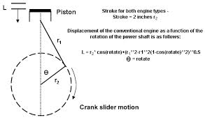

Figure : Crank Rod

* 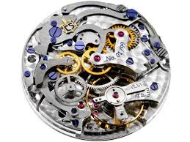 **Watch Mechanism** (Figure 18: Watch mechanism) – On the watch mechanism we were able to analyze the turning (endless worm – Figure 19: Endless worm) mechanism and see if we could make any adaptions to our prototype.

Figure : Watch mechanism

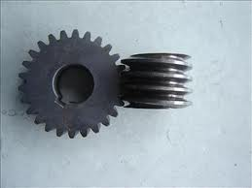

Figure : Endless worm

### Version 3.0

For the third version of the dark horse we looked for a couple of support mechanisms for the user´s foot. We decided to take this direction considering user’s feedback from the previous prototype.

* **Wheelchair support** (Figure 20: Unitary wheelchair foot support and Figure 21: Dual wheelchair foot support) – The wheelchair support was considered as a part of the benchmarking research once it is already used for our target group.

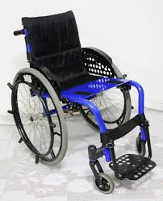

Figure : Unitary wheelchair foot support

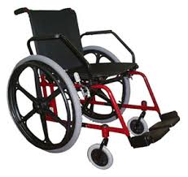

Figure : Dual wheelchair foot support

* **Office Skate** (Figure 22: Office skate) - This is a product used to give support for the employee’s feet giving at the same time capacity to move. That could be used on our product to allow the sliding of the passenger’s feet.

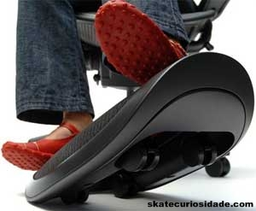

Figure 22: Office skate

## Construction

### Version 1.0

The first prototype of our dark horse idea was a paper one to provide the correct vision of our product and give insights for the real scale one. In order to do that we use simple materials as paper, matchstick, clay and glue as show on Figure 23: Paper prototype sketch, Figure 24: Toilet seat being glued, Figure 25: Mechanism being tested and Figure 26: Dark Horse version 1.0.

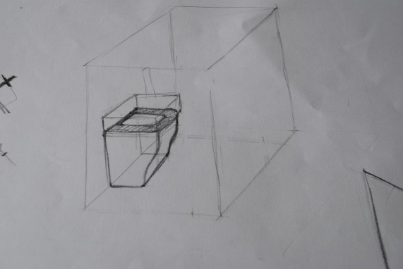

Figure : Paper prototype sketch

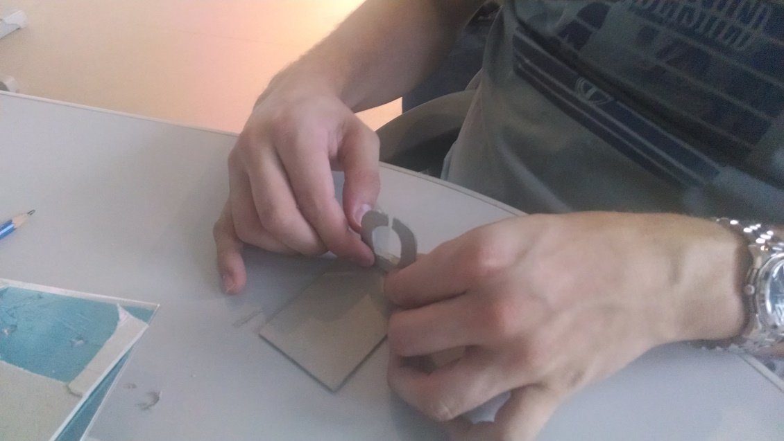

Figure : Toilet seat being glued

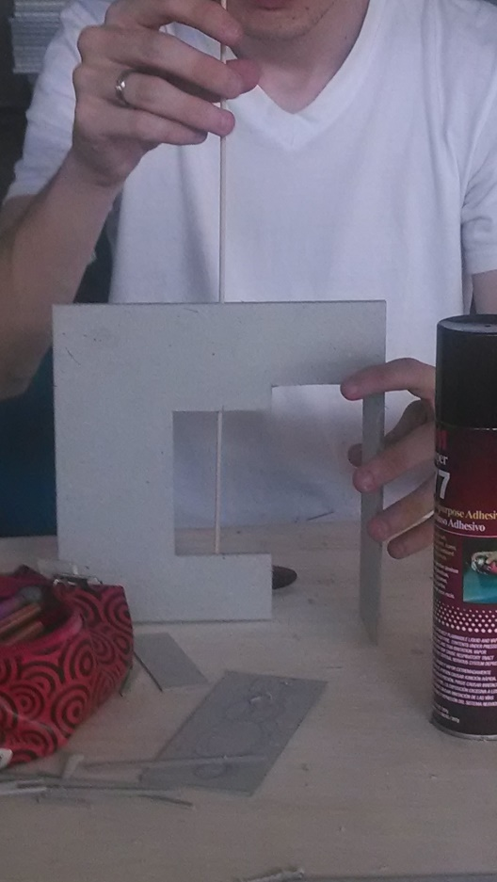

Figure : Mechanism being tested

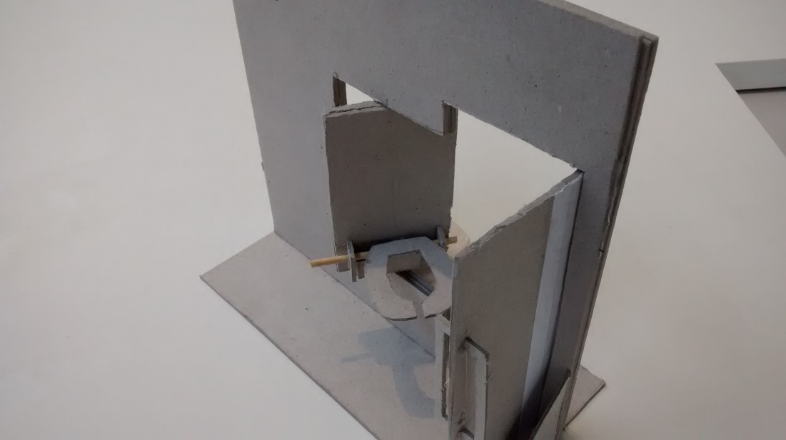

Figure : Dark Horse version 1.0

### Version 2.0

On this version of the Dark Horse we managed to make a real scale prototype to try to understand how users would react with this product and at the same time identify possible design failures and how we could improve it.

Our quest started by searching for materials that could bear the weight of a human being and also that could allow the turning mechanism to exist. A 30mm fiberboard proved to be strong enough for our needs, while the pivotable hinge provided us with the rotational movement we needed. Other than that, we used a retractable hinge to simulate the flight crews’ retractable seat.

After that we cut the fiberboard, built the prototype and tested it with some people from outside the design group, but that did not had mobility issues as shows Figure 27: Woodwork - Dark Horse, Figure 28: Testing the resistance of the turning seat and Figure 29: Testing with people outside the group. Unfortunately, because our prototype was huge and heavy, it couldn’t be easy transported and because our campus has not many wheelchair users, we were not able to test it with our actual target users.

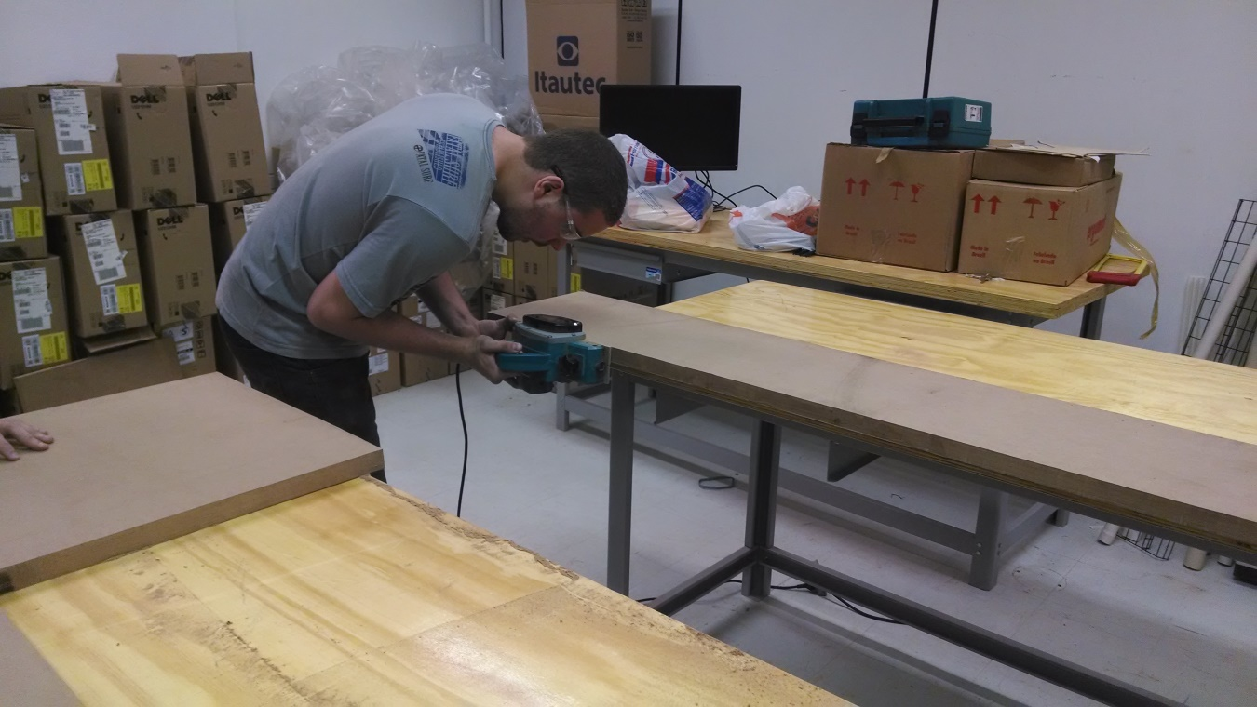

Figure : Woodwork - Dark Horse

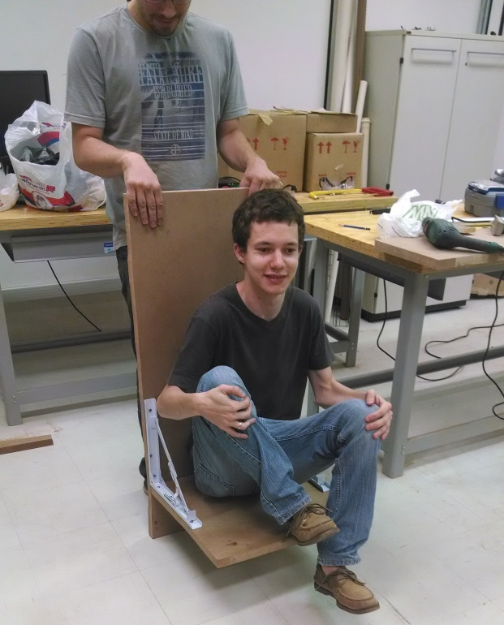

Figure : Testing the resistance of the turning seat

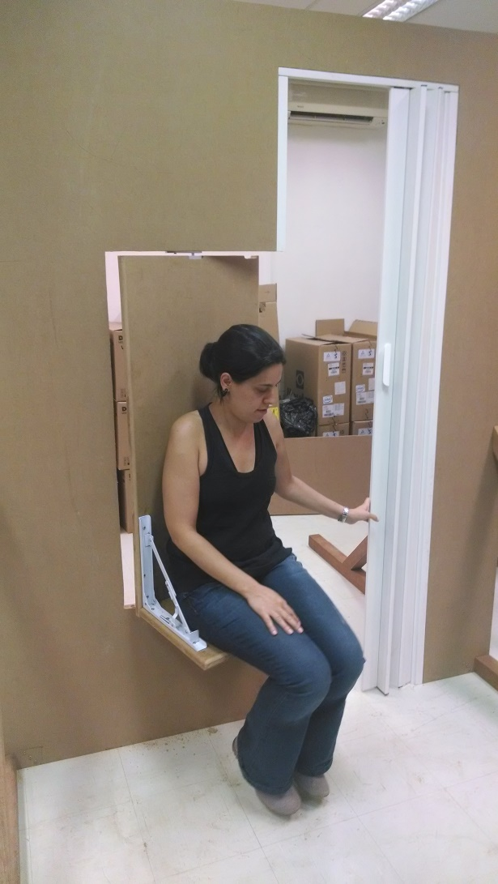

Figure : Testing with people outside the group

### Version 3.0

On this version we tried to build a more complex turning mechanism that would provide greater independence for our user. Besides that we managed to create a mechanism for the feet and tested with some people outside the group with no mobility issues and asked for the opinion of one potential user. First, we printed a couple of gears and tried to create a turning mechanism and then we designed the feet mechanism and tested it with more people.

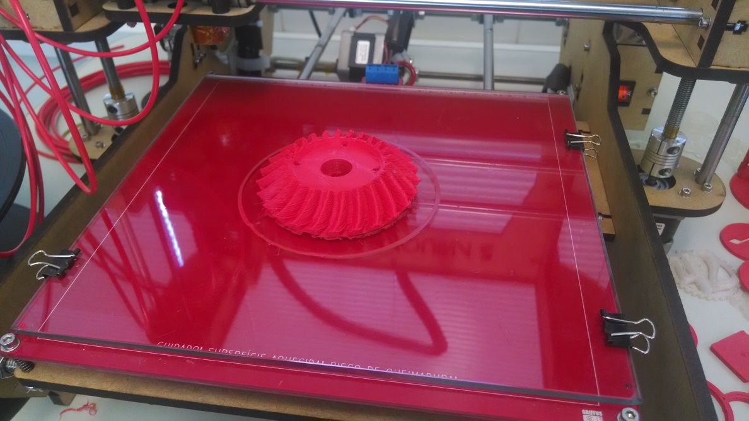

Figure : 3D - printed gear

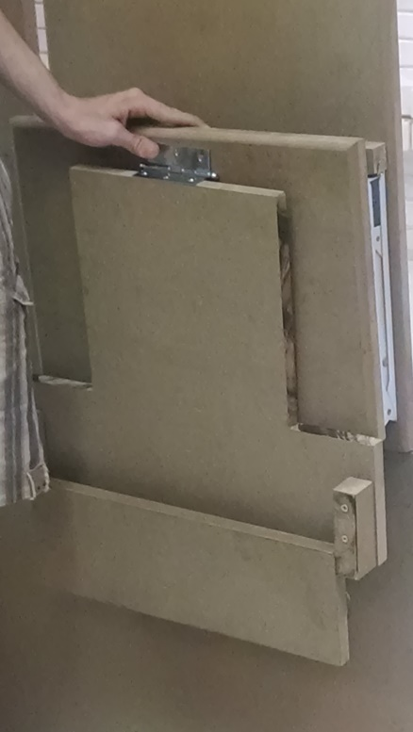

Figure : Seat support mechanism

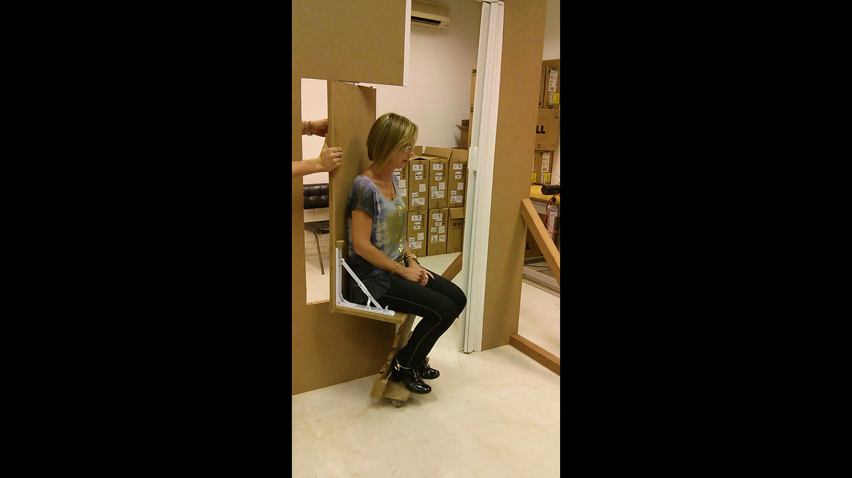

Figure : Version 3 being tested

## Learnings and Feedback

### Things we learned

* Privacy and autonomy are of utmost importance for our users.
* The way that the user removes his pants needs to be thought.
* Rotating mechanism does not necessarily have to be motorized. It could be just a mechanic system, avoiding thus the increase in energy consumption and weight;
* The gap between the rotating wall and the structure wall must be sealed;
* Having the right tools can make the prototyping process much faster;
* The footrest has to allow a smooth transfer. Rotating wheels do not comply with this requirement.
* Because of the friction of the wheels, the force needed to rotate the chair increases considerably. A better solution would include a “floating” adjustable footrest.
* The footrest angle must be adjusted so as to provide comfort for the user.
* **The current airplane lavatories do not have enough space to accommodate the rotating toilet seat.**
* Hygiene must be taken into consideration as you are exposing the airplane to potential pathogenic agents when the wall is rotated.

### User Feedback

* Our interviewee Cid Torquatto told us that he would actually use the solution and that it is a great way to encourage reduced mobility people use the bathroom on airplanes;
* The seat must have more depth and be wider, because the way it is now it feels like one could fall from it;
* Rotation mechanism is safer using a manual solution rather than an automatic one;

**Funktional Prototype**

**Ideation**

After the Dark Horse prototype, the team gathered important feedback from testers and from Embraer and decided to embrace a new line of thought: how can we make the access easier inside the airplane to people with reduced mobility?

Our benchmark and interviews showed us that the transfer is one of the most demeaning moments for the handicapped, so the team focused on making the user more independent while transferring.

**Candidates**

The team agreed that the prototype should make the transfers inside the airplane so easy that the person on the aisle wheelchair could make the transfer by himself without major efforts. After a brainstorm, the team had two ideas for making this transfer: a sliding seat and a **comb mechanism in which a male/female coupling system would allow the user to be transferred. (add picture of skectches).** The former mechanism was chosen because it was simpler to build and lighter, as it did not require a motor to lift the user or a counterweight to stabilize the chair.

With that in mind, we benchmarked existing mechanisms that were used to make linear transfers. These mechanisms are listed below:

1. **Linear Guide (Figure 10)**

The rails would be installed on the aisle wheelchair and the seat, while the carriage would be installed on the cushion. The cushion would be able to slide from one seat to the other if the seat and the wheelchair were correctly paired.

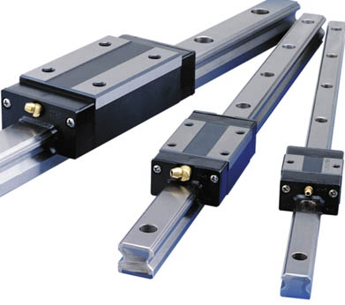

Figure Linear guide

The negative aspect of the linear guide is that it would require a milimetric precision when pairing the aisle wheelchair with the seat. We found this to be unrealistic, especially when we took in consideration that the solution would not necessarily be automated.

1. **Conveyor rollers (Figure 11)**

The mechanism would use the same principles of a conveyor table, where one can move heavy objects by sliding them on top of conveyor rollers. This mechanism would be installed on the seat and the aisle wheelchair, allowing the cushion with the user to slide.

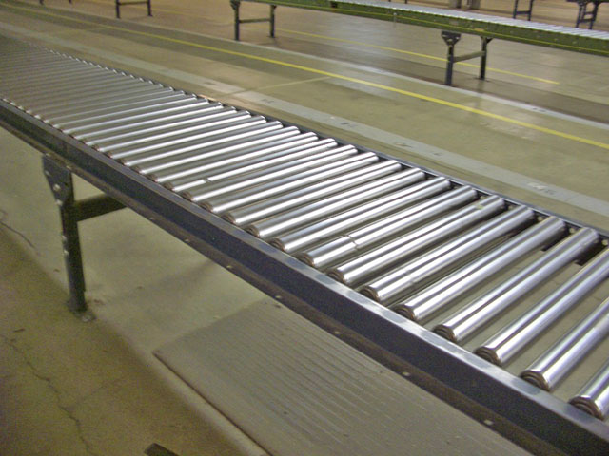

Figure Conveyor rollers

This was a good solution, given our time constraint and budget.

1. **Ball transfer table (Figure 12)**

The mechanism would work as the previous one, where the cushion would be able to slide from the aisle wheelchair to the seat, but using spheres instead of conveyor rollers. These spheres are lighter than the previous solution and as a result were more appropriate for our design

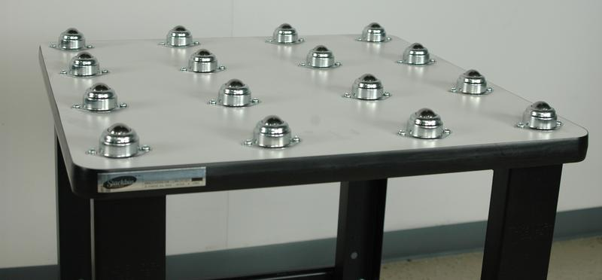

Figure Ball transfer table

Unfortunately the team could not find a supplier that could provide the components in time to build the prototype with an affordable cost, so the mechanism with conveyor roller was chosen.

Based on what was discussed above, the team decided to implement the seat with conveyor rollers to enable the sliding movement of the seat (Figure 36). With the same mechanism installed on the aisle wheelchair, one would be able to easily transfer oneself laterally from the aisle wheelchair to the seat and vice versa without major efforts.

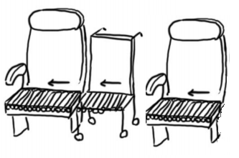

Figure Idea of the mechanism

**Construction**

In our first attempt to build the prototype (Figure 14) the high friction made the sliding movement extremely difficult. The main reason for this failure was that our initial assumption that the aluminum cylinder directly attached to the wooden structure would be enough to make the rolling movement was false.

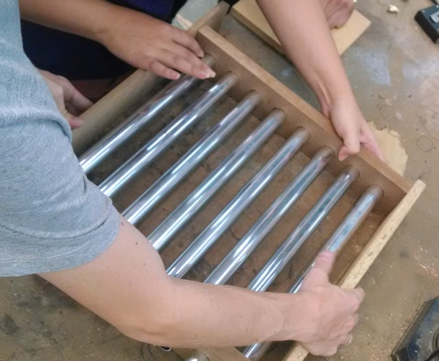

Figure First build attempt

In order to overcome this issue, we added bearing to both ends of the cylinders (Figure 14 and Figure 15). This solved the friction problem, making the whole mechanism work as we had designed it (Figure 16).

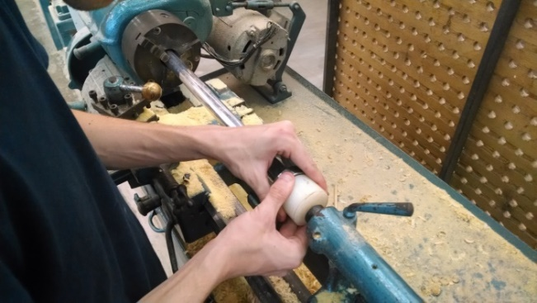

Figure – Fixing Bearings

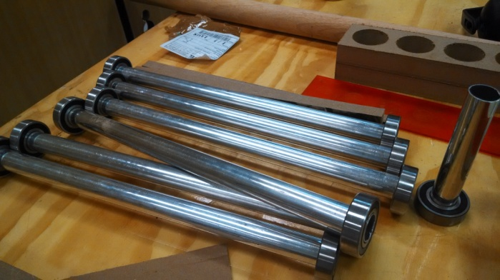

Figure - Fixed bearings

Next, we tested the sliding mechanism with different types of materials on the cushions base. First we tried adding an adherent surface (rubber) to see how the mechanism would slide. We noticed that it was quite hard to overcome the static friction. Afterwards we tried adding a semi-rigid plastic base. Although the transfer was quite easy, one could feel the cylinders while sliding. As a result, we chose to use a hard flat base under the cushion to make it slide smoothly.

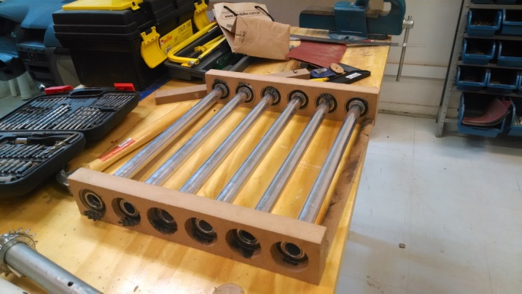

Figure Final mechanism

**Learnings**

* The friction between the aluminum cylinder and the wood is too intense for a user to transfer from one seat to another;
* The space between the cushion and the mechanism must be considered to avoid at the same time increasing the friction and the looseness of the cushion (rotating movement);
* Cushion must be firm enough so that the user does not feel the cylinders and to allow proper transfer;
* Correct alignment between the aisle chair and the seat is very important.
* Armrest must be retractable.

**User Feedback**

* The issue that we dealt with is not as critical as the lack of accessibility of the lavatory.

**Functional Prototype**

As the Funktional prototype was a relative success the team decided to step forward and work on the latching mechanism of the seat and also on the retractable armrest.

**Benchmarking**

**Door Lock**

This mechanism below (figure xx) can be fixed on the ground and is normally used to lock doors. On our case, this mechanism could be fixed to the cushion, allowing the user to effectively lock his cushion by rotating the key.

<http://www.lockers.com.br/wp-content/gallery/travas-de-alta-seguranca/trava_panzer_modelo_02.jpg>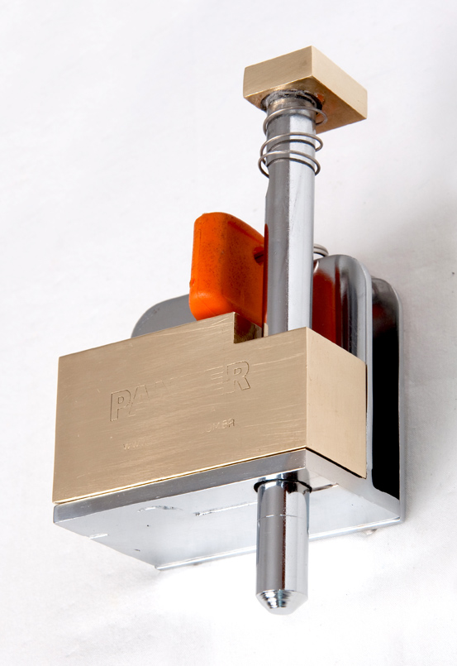

Figure – Door locking mechanism

**Multi purpose lock**

The multi purpose lock (figure xx) can be used to lock several mechanisms such as doors and windows. In order to do so, the user has to open the latch showed on the right part of the image and hook it to the piece represented on the left part of the image.

<http://isuba.s8.com.br/produtos/01/00/item/110988/2/110988216SZ.jpg>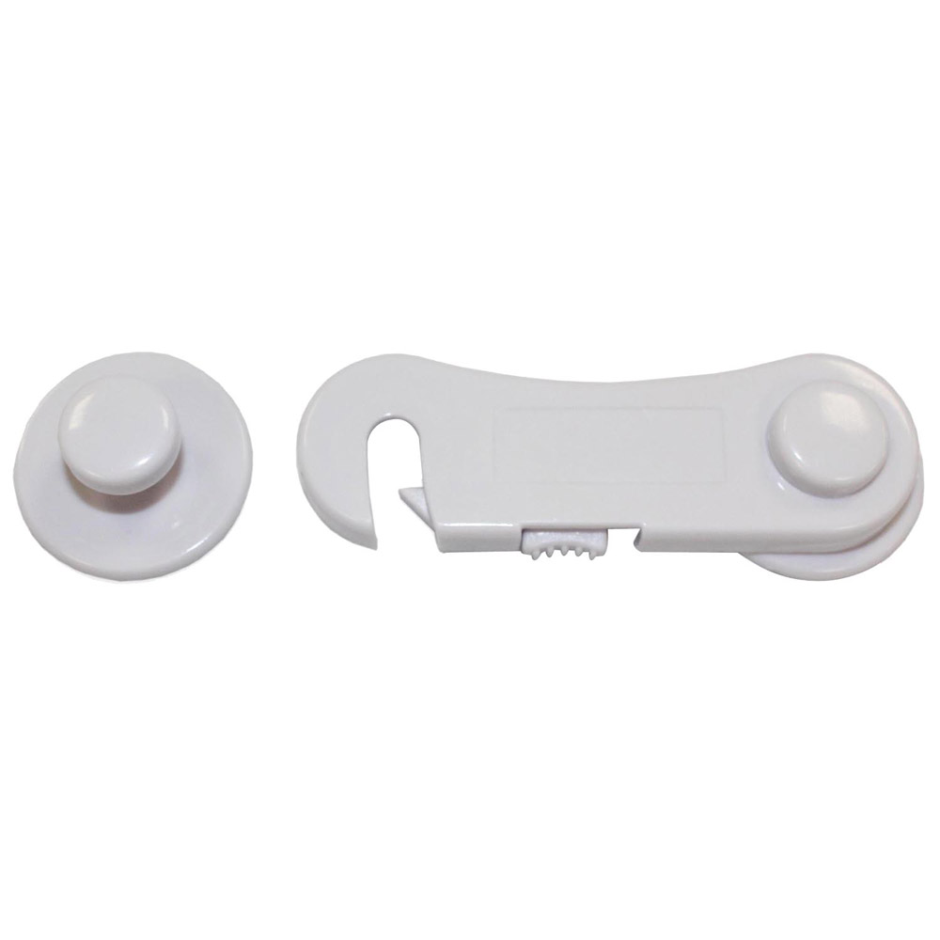

Figure – Multipurpose lock

**Seat slide adjustment mechanism**

This mechanism (image xx) is a horizontal adjustment to use with a chair having a base, a seat supported on the base and a seat back. The mechanism includes a first plate that is to be coupled to the base and a second plate that is coupled to the seat. The second plate includes a mating portion. The second plate is slidably coupled to the first plate such that the second plate can move relative to the first plate. The mechanism also includes a lever mechanism. The lever mechanism includes a mating portion that selectively disengages from the mating portion of the second plate to allow the second plate to move relative to the first plate.

[**http://www.freepatentsonline.com/7159942.html**](http://www.freepatentsonline.com/7159942.html)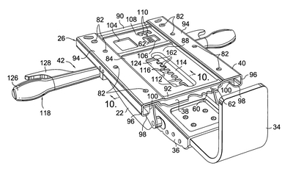

·

**Ideation**

Based on the benchmarking we did, we did a brainstorming session (Figure 43) to find better solutions for our project. As we were brainstorming, we noticed that, ideally, the movement of the armrests should be associated with the latching mechanism. The reason for this is that the user has necessarily to lift his armrest in order to complete a transfer.

From this ideation process, two main solutions were proposed:

* a “Tetris” armrest that would lock the cushion when it was lowered.
* a system in which a wire would be attached to the armrest and pull a pin when the armrest was retracted, unlocking the seat. A spring/rubberband on the other hand would lock the mechanism when the armrest was lowered (Figure 44).

By analyzing both options, we noticed that the first one added unnecessary weight and bulk to the solution and therefore was discarded. The second option on the other hand is a more elaborate and discrete solution, automatically locks the seat, even if the cushion is not precisely positioned and lastly provides a sonorous feedback when the seat is latched.

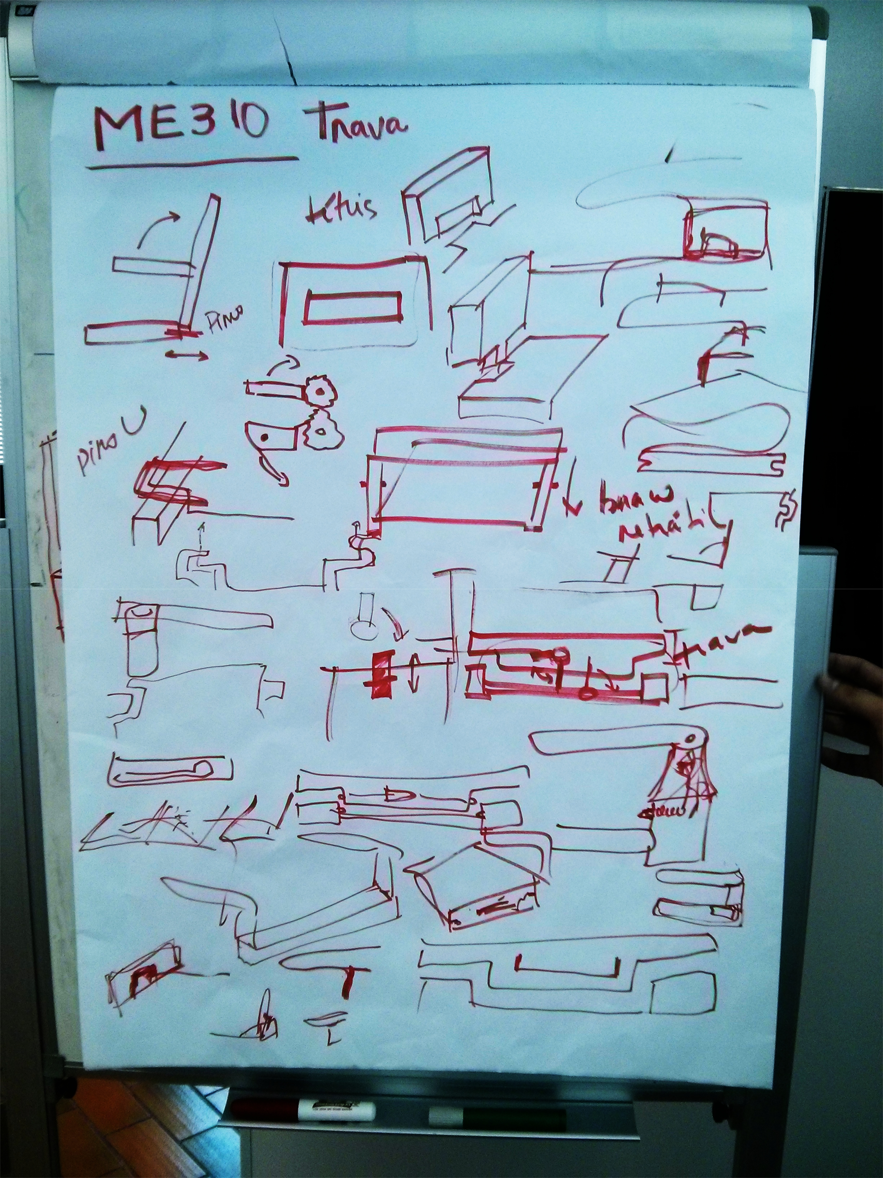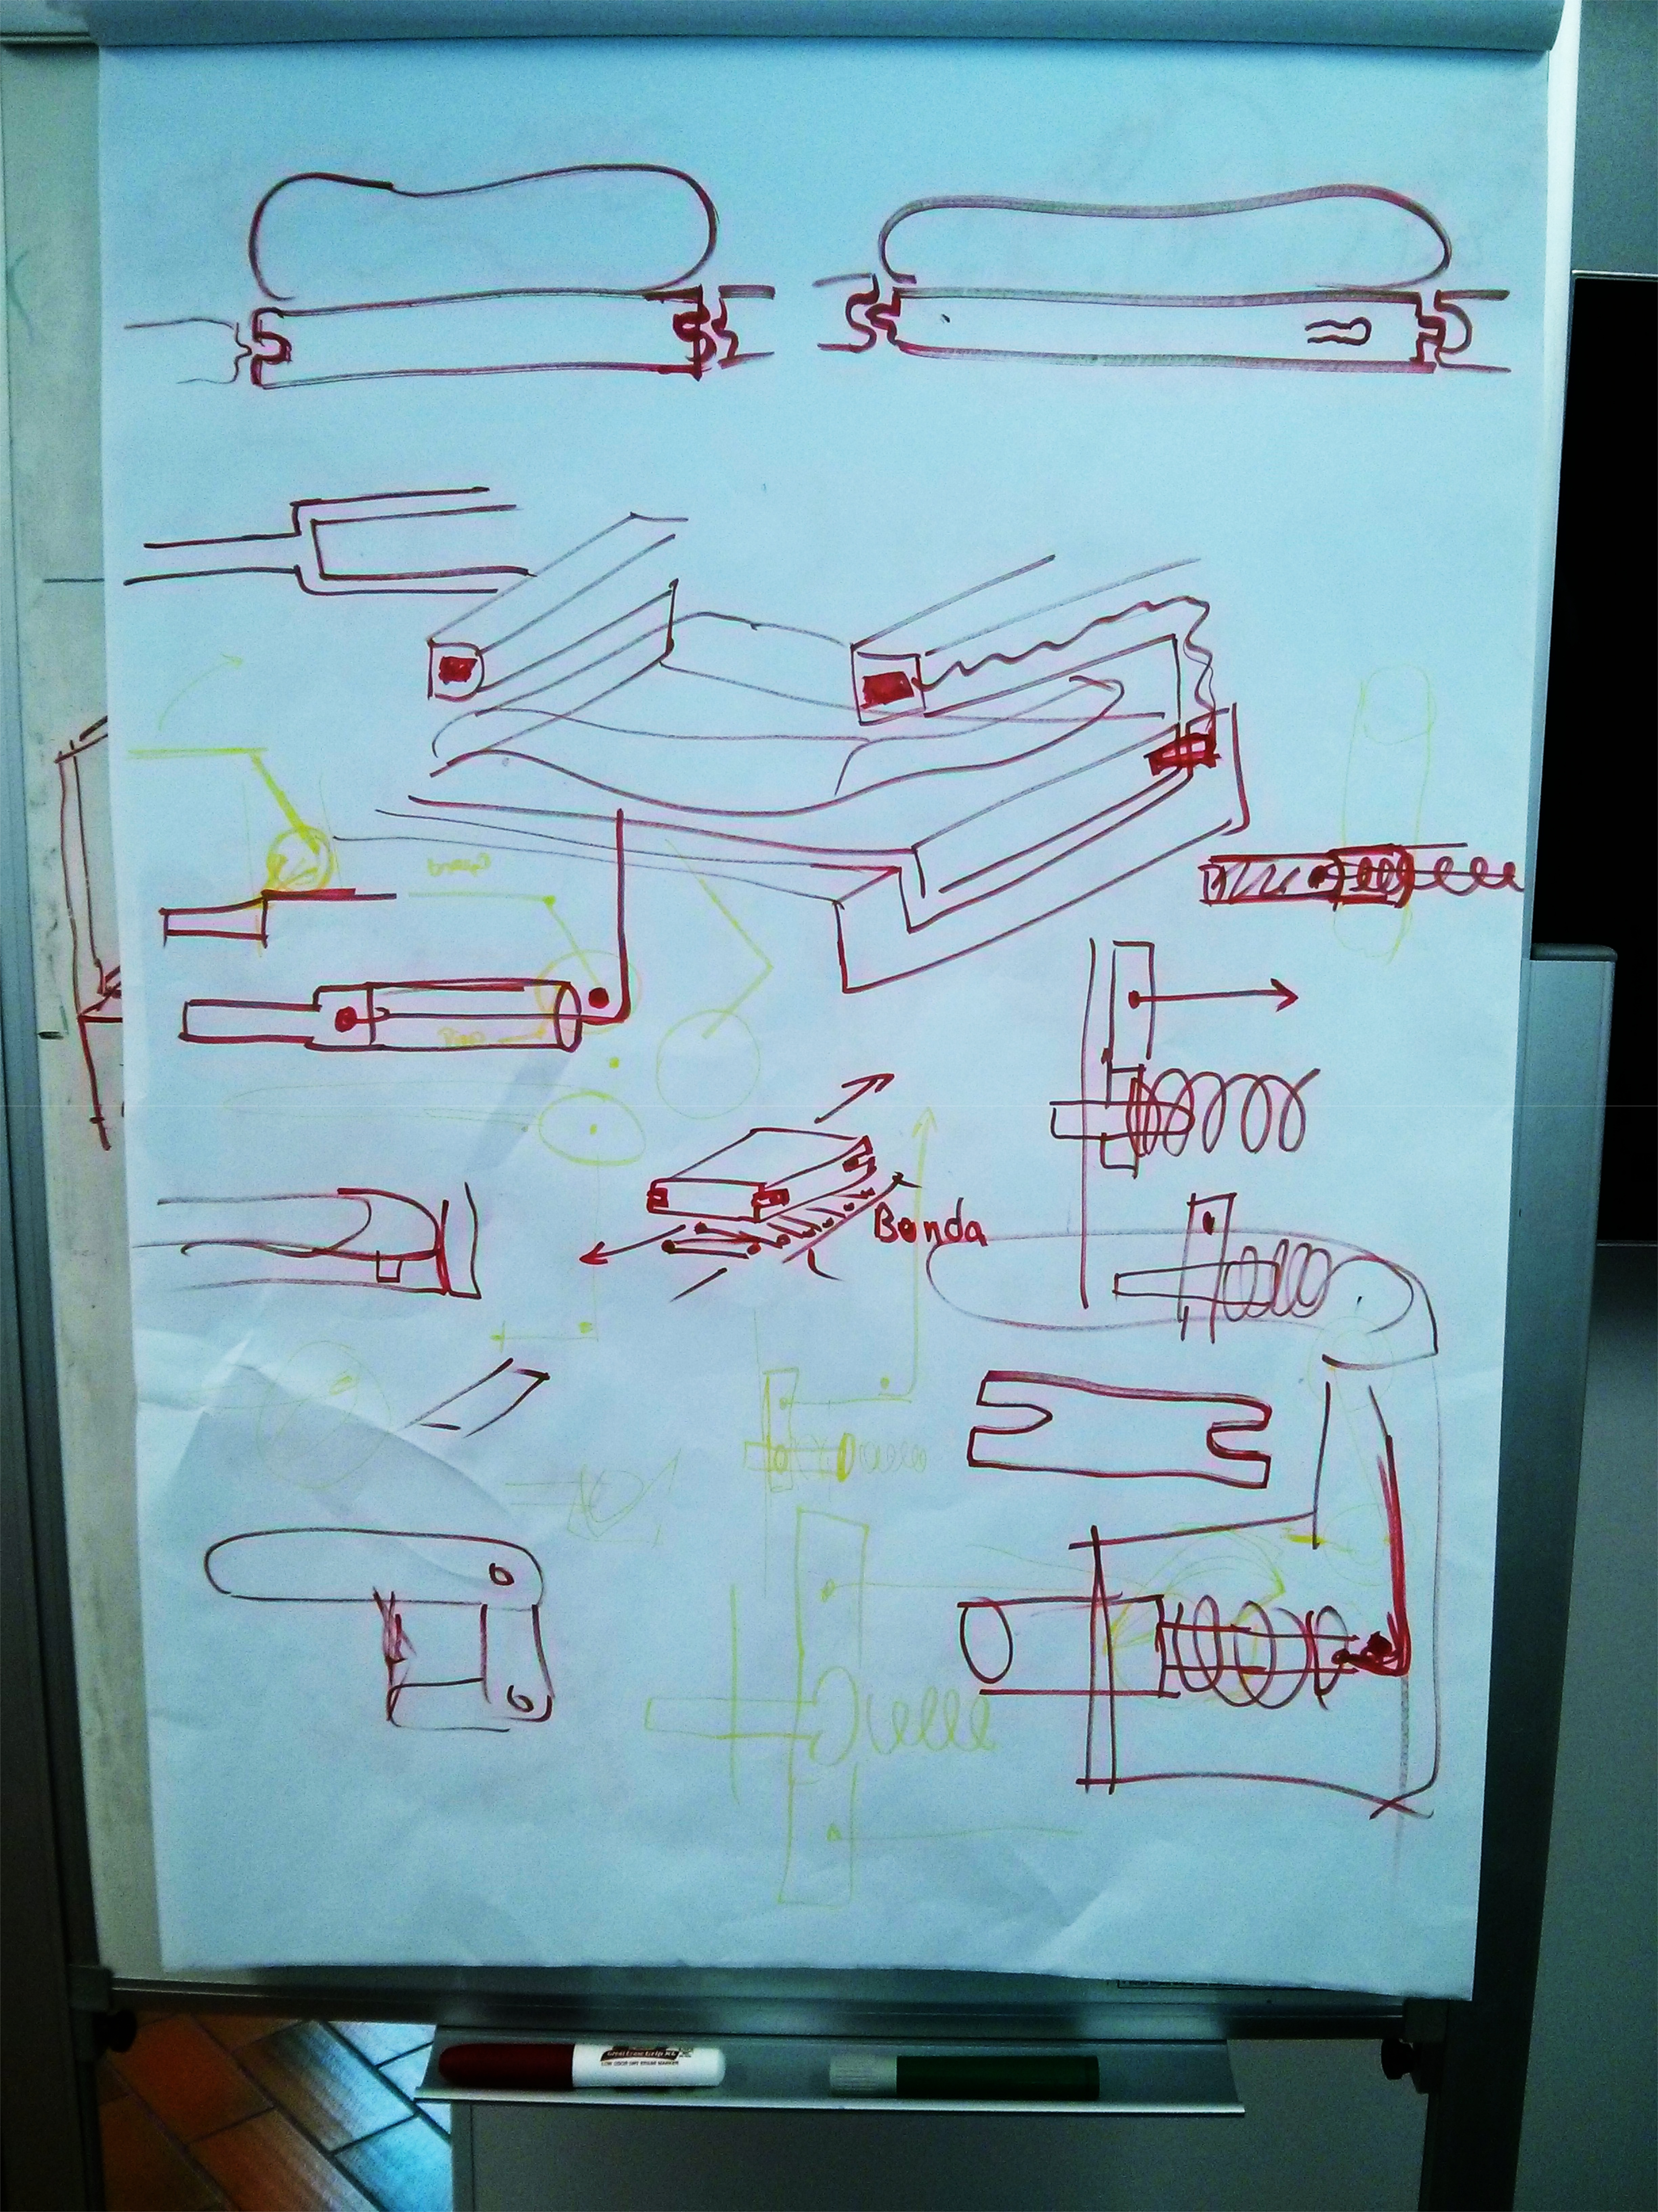

Figure - “Chaotic” Brainstorming session

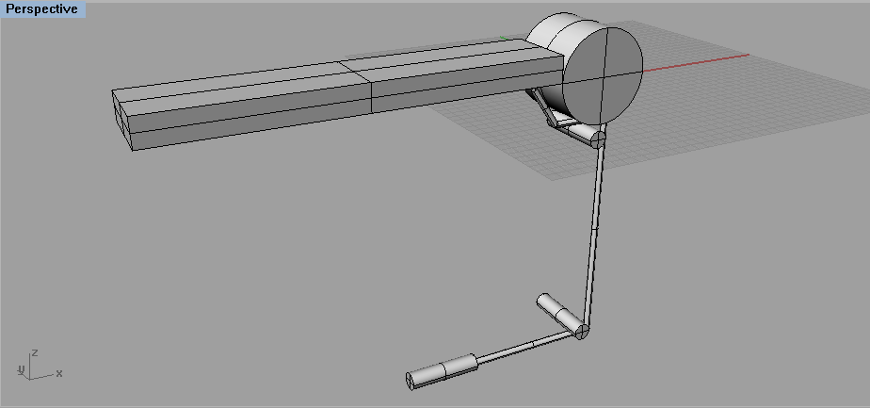

Figure – Chosen latching mechanism

**Construction**

By using some aluminum cylinders leftovers from the workshop and some pieces of wood we assembled a couple of retractable armrests (Figure 41) that could be attached to funktional prototype. We also used a 3D printer to create a pin that literally latches the cushion.

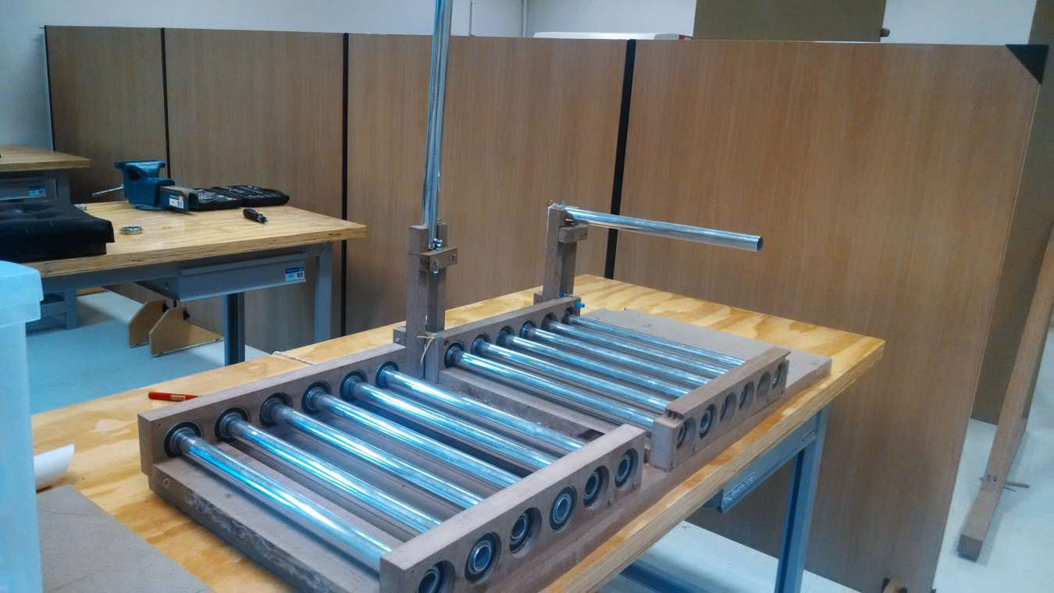

Figure Retractable armrests

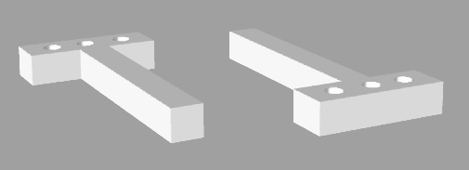

Figure : 3D model of printed pin

Figure 47 shows how the armrest mechanism works. The image on the left shows how the mechanism behaves when the armrest is retracted, while the image in the right shows the mechanism locked (armrest down).

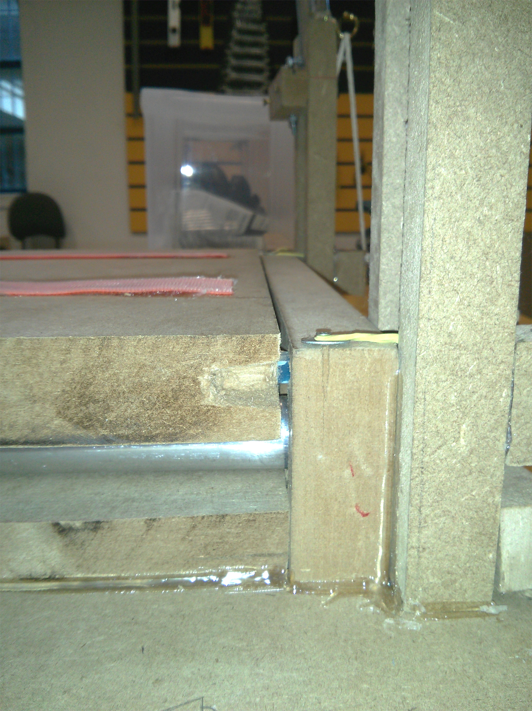 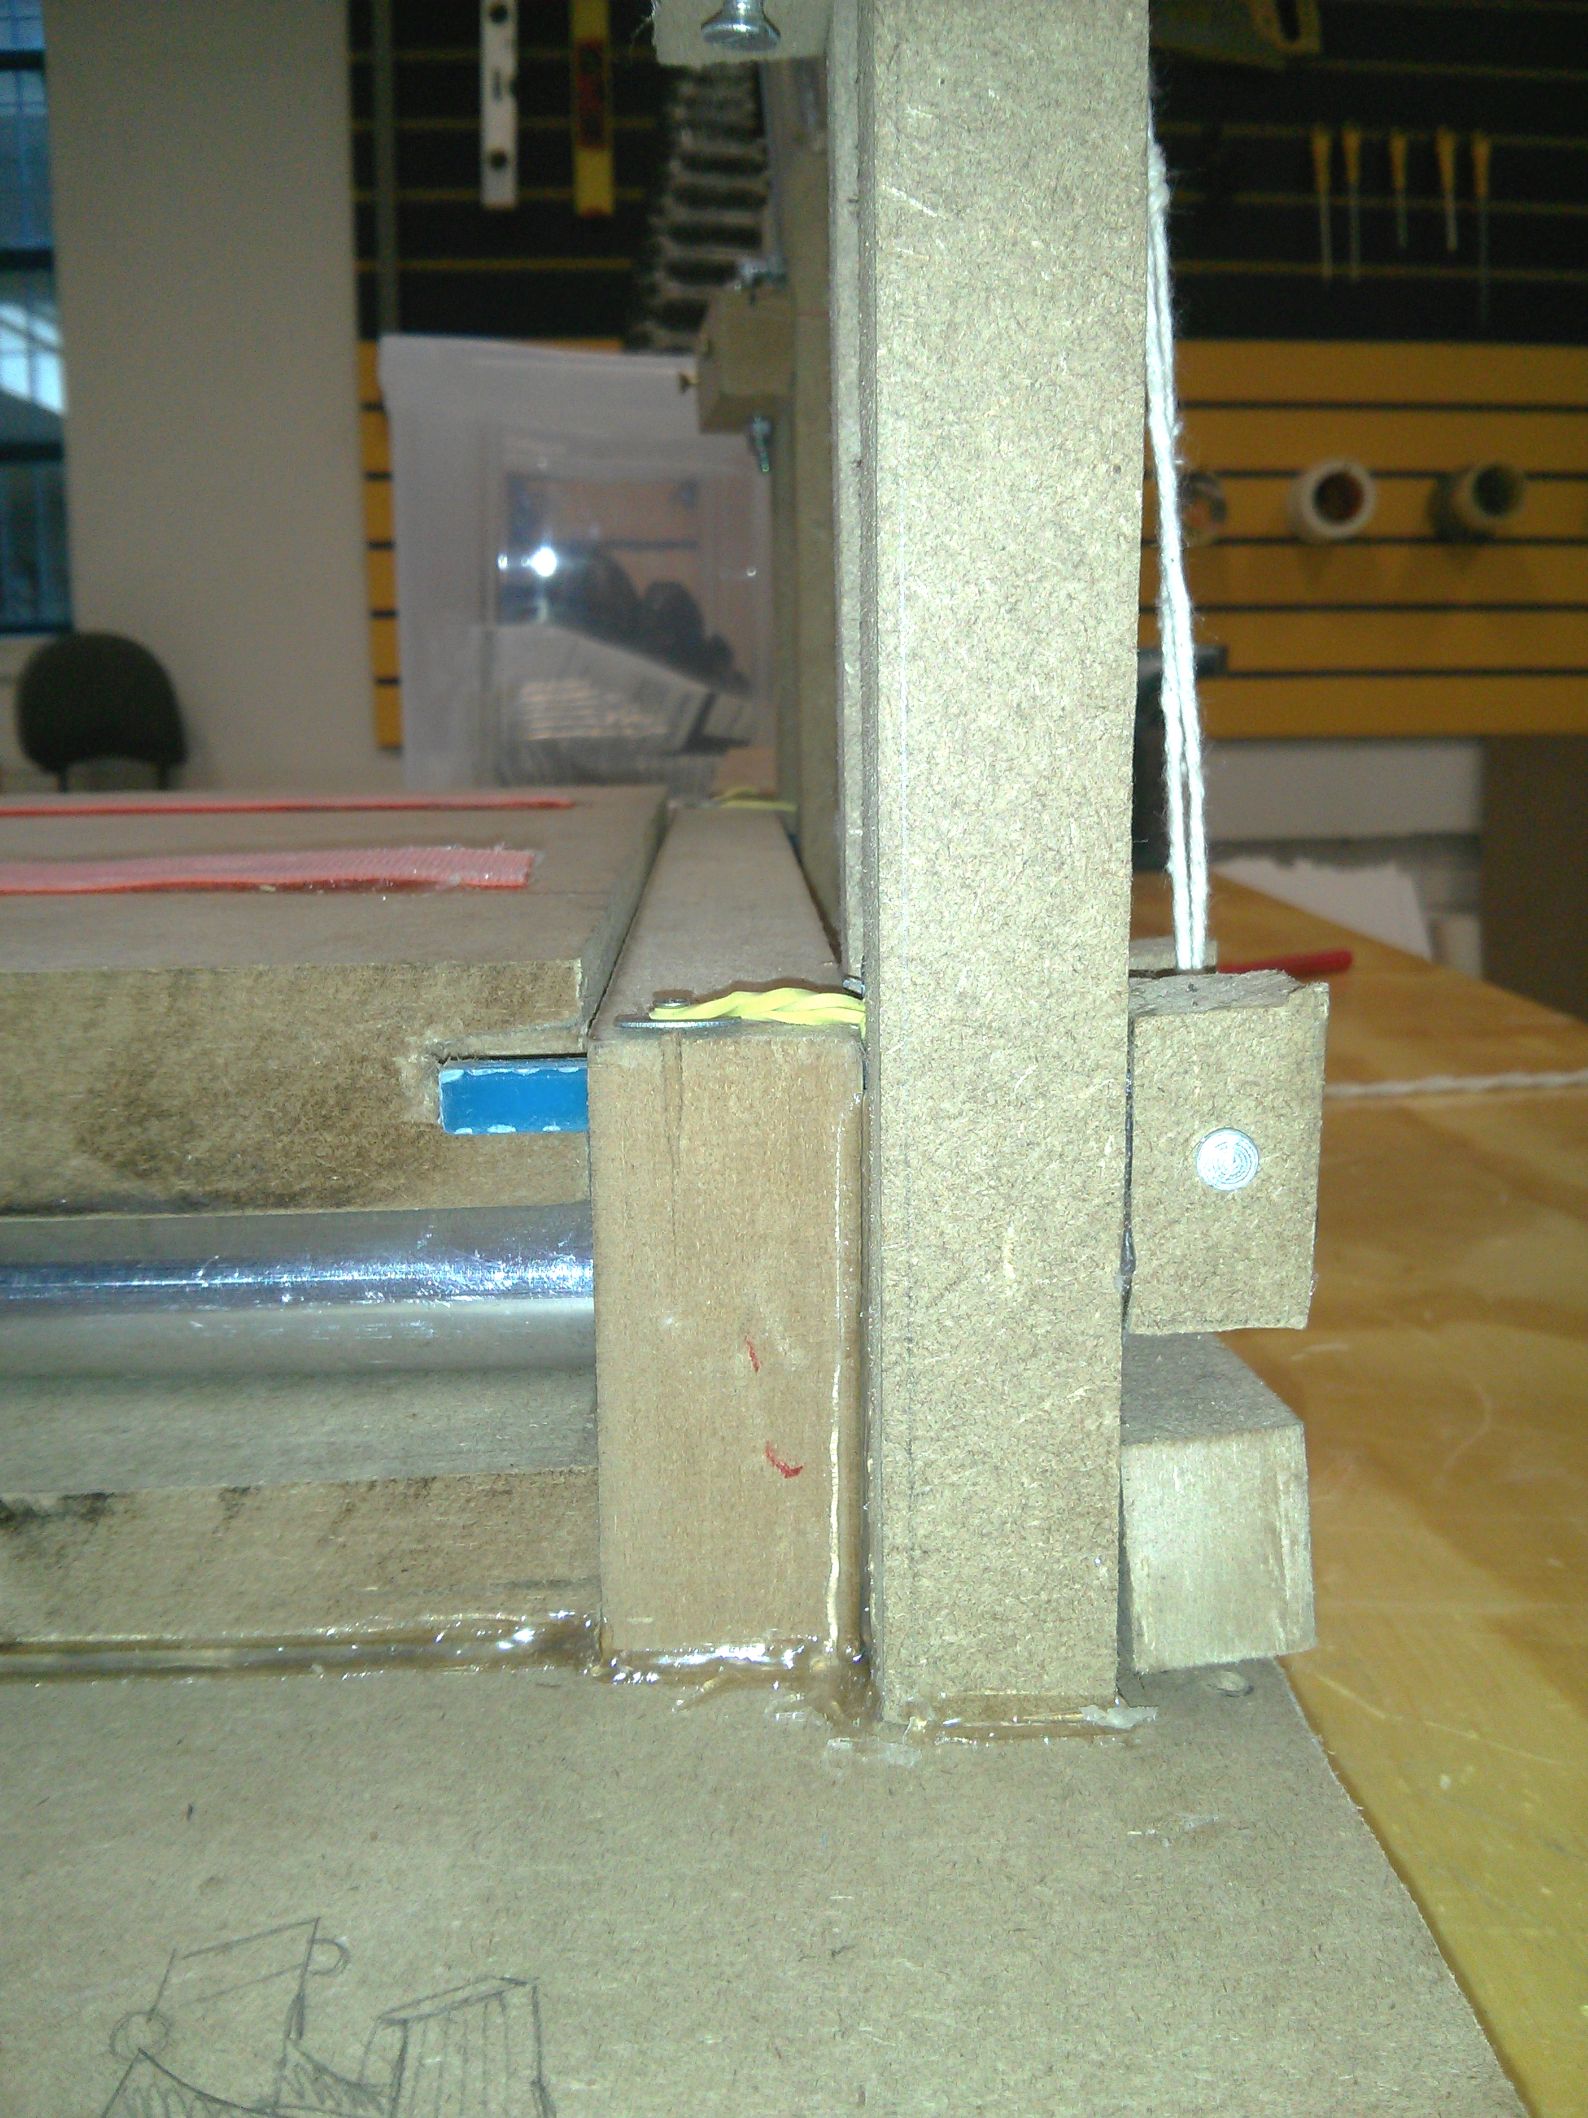

Slot in cushion base

Retracted Pin

Locked Pin

Rubber Band

Figure – Unlocked cushion (left), locked cushion (right)

The rear view of the mechanism is shown below onFigure 48:

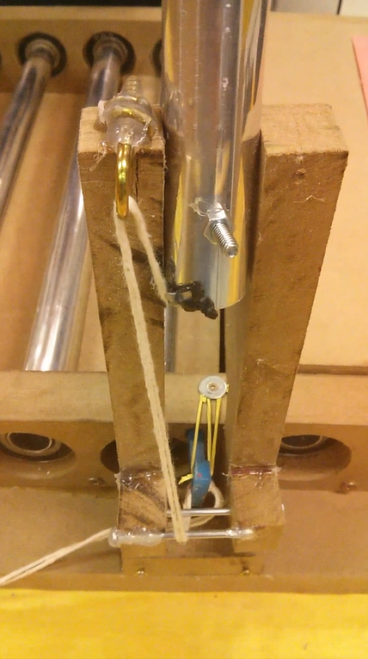

Figure – Rear view of mechanism

**Learnings**

* It is possible, quite easy and comfortable to make a lateral transfer.
* Understanding how the mechanism will be used is crucial for achieving a user-friendly design. For instance, by simulating how a transfer would be made by an user, we noticed that it made sense to link the latching mechanism with the movement of the armrest. Armrest up, seat unlocked and vice-versa. We had several options for locking the seat, but we insisted in finding one that would be intuitive for the user. This proved to be a good design choice.
* Our conveyor rolling mechanism is not viable because it required too many alterations of the airplane and added too much

Procuramos pesquisar mecanismos de trava e referencias de cadeiras com braços removíveis para entender e usar de referencia para novas soluções.

Braços removíveis

<http://imagensocean.institutosaopaulo.com.br/000000000003350/533/cadeira-de-rodas-agile-fat-1.jpg>

trava de cofre

<https://www.youtube.com/watch?v=mJQdxER9Hto>

trava loker

<http://www.lockers.com.br/wp-content/gallery/travas-de-alta-seguranca/trava_panzer_modelo_02.jpg>

trava

<http://isuba.s8.com.br/produtos/01/00/item/110988/2/110988216SZ.jpg>

trava de ajuste de cadeira

[**http://www.freepatentsonline.com/7159942.html**](http://www.freepatentsonline.com/7159942.html)

**trava para descanço de braço**

[**http://www.freepatentsonline.com/6644746.html**](http://www.freepatentsonline.com/6644746.html)

**trava para descanço de braço (2)**

[**https://data.epo.org/publication-server/rest/v1.0/publication-dates/20001213/patents/EP105 9193NWA2/document.html**](https://data.epo.org/publication-server/rest/v1.0/publication-dates/20001213/patents/EP1059193NWA2/document.html)

# Bibliography

ASSOCIAÇÃO BRASILEIRA DE NORMAS TÉCNICAS. **NBR 9050:** Acessibilidade a edificações, mobiliário, espaços e equipamentos urbanos. Rio de Janeiro, 2004.

<http://pvamag.com/pn/article/4576/accessible_skies> - accessed 03/15/2014 4:08PM